`



Software Measurement Process

Van Lang Admissions

# Revision Table

|  |  |  |  |
| --- | --- | --- | --- |
| Author | Date | Reason for changes | Version |
| Tai Nguyen | 3/11/2016 | Measurement Process | 1.0 |
| Tai Nguyen | 4/11/2016 | Update Process | 1.1 |
| Tai Nguyen | 12/1/2017 | Format Style | 1.2 |
| Khoi Nguyen | 24/5/2017 | Fix template | 2.0 |

Table of Contents

Revision Table 1

1. INTRODUCTION 3

1.1. Purpose 3

1.2. Audience 3

2. Process 4

2.1. Process flow 4

2.2. Activities 6

2.3. Roles and Responsibility 6

2.4. Goal-Questions-Metrics (GQM) 7

Metric Definition 8

# INTRODUCTION

## Purpose

## Audience

The intended audience of the Measurement Plan is

|  |  |
| --- | --- |
| Intended Audience | Description |
| Measurement Leader | Draw process and guide member |
| Customer | Follow Work progress of team |
| Project manager | Manage team and measure cost |
| Mentor | Review and give advice for process |

# Process

## Process flow

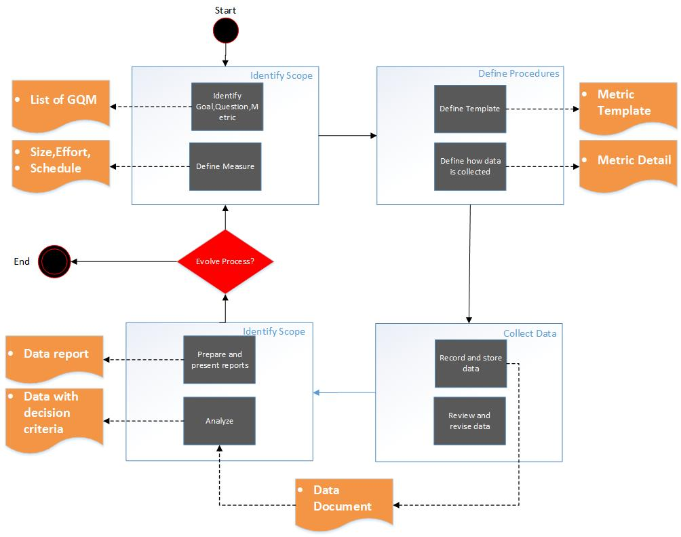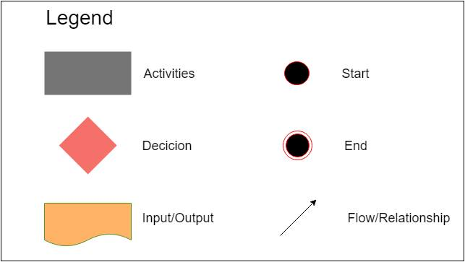

## Activities

|  |  |  |
| --- | --- | --- |
| **Phases** | **Activities** | **Description DeD** |
| Identify Scope | Identify Goal, Question, Metric | Identify goal of project, all question is  Collected by member, show some  Metric to solve problem |
| Define Measure | monitor actual versus estimated size, effort, and schedule in order to make decisions with respect to project plans, progress,  and need for re-planning |
| Define Procedures | Define Template | Collect Template for recording data |
| Define how data is collected | Establish a measurement plan |
| Collect Data | Record and store data |  |
|  | Review and revise procedures | collection procedures are adequate |
| Analyze Data | Prepare reports | Prepare template for presenting |
| Analyze and present reports | report is understood and acceptable |

## Roles and Responsibility

|  |  |
| --- | --- |
| **Roles** | **Responsibility** |
| QA Management | Identify scope, issues and assign roles, task for member also choose measurement process to control project. |
| Recorder | Collect data |
| Analyst | Analyze data and store data |

## Goal-Questions-Metrics (GQM)

|  |  |  |  |
| --- | --- | --- | --- |
| **Goal** | **Questions** | **Metric** | **Objectives** |
| Ensure the actual project duration is within 10% percent of the committed duration | How current time diference with planned? | $\frac{Actual time}{Estimate time }$ | Time |
| Ensure the total cost won’t exceed 10% of the initial budget | How current buget diference with planned? | $$\frac{Current buget}{Initial budget}$$ | Cost |
| Ensure the quality of product | How many is current defect found on funtion? | $$\frac{Total defects found}{KLOC}$$ | Quality |
| How many is defect fixed? | $$\frac{Defect fixed}{Defect found}$$ |
| How many is test-case pass? | $$\frac{Test-cases pass}{Total test-cases}$$ |
| Ensure team morale always happy to their work success | How does member feel about their job? | Survey | Team morale |
| $$\frac{Absent day}{Total team meeting}$$ |
| Ensure satification of customer always high | How do customer feel about product? | Survey | Customer satification |

## Metric Definition

|  |  |
| --- | --- |
| **Name** | $$\frac{Actual time}{Estimate time }$$ |
| Definition | Parameter:  Actual time (A)  Estimate cost (E)  If A / E:  1: On time.  < 1: Early.  > 1: Late. |
| Goals | Use to measure progress of product to evaluate current status of product. |
| Frequency of collection | Each week |
| Responsibility | Gatherer |

|  |  |
| --- | --- |
| **Name** | $$\frac{Current buget}{Initial budget}$$ |
| Definition | Parameter:  Current buget of phase (CB)  Initial buget of phase (IB)  If CB / IB:  1 : On budget  < 1: Low budget  > 1: Over budget |
| Goals | Use to measure buget of product to control cost on buget |
| Frequency of collection | Each phase |
| Responsibility | Gatherer |

|  |  |
| --- | --- |
| Name | $$\frac{Total defects found}{KLOC}$$ |
| Definition | Parameter:   * Total defects found (TDF) * Kilo line of code (KLOC) |
| Goals | Evaluate and control quality of product. |
| Frequency of collection | Each funtion completed |
| Responsibility | Gatherer |

|  |  |
| --- | --- |
| **Name** | $$\frac{Defects fixed}{Defects found}$$ |
| Definition | Parameter:   * Defects fixed (DF) * Defects found (F)   If DF / F:   * 1: all defects fixed. * < 1: product still had defect need be fix. |
| Goals | Evaluate and control quality of product. |
| Frequency of collection | Each funtion completed |
| Responsibility | Gatherer |

|  |  |
| --- | --- |
| Name | $$\frac{Test-cases pass}{Total test-cases}$$ |
| Definition | Parameter:   * Test-cases pass : (TP) * Total test-cases (TT)   If TP / TT:   * 1: product has not defect. * < 1: product still had defect. |
| Goals | Evaluate and control quality of product. |
| Frequency of collection | Each funtion completed |
| Responsibility | Gatherer |

|  |  |
| --- | --- |
| **Name** | **Team morale survey** |
| Definition | Question:   1. How happy are you with your company? (Score 1 -> 5) 2. Are members enthusiatic and energetic about their team and their work? 3. Are members willing to take one for the team? 4. Are members proud of their team and their work? 5. Are members happy to be part of the team? 6. Are members feeling valuable to the team? 7. Are members happy with their tasks?   If average score all question above:   * = 5: High morale, happy with team * < 2,5: Low morale need team meeting to solve that problem |
| Goals | Evaluate and monitor morale member to control quality of their work. |
| Frequency of collection | Each week |
| Responsibility | Gatherer |

|  |  |
| --- | --- |
| **Name** | $$\frac{Absent day}{Total team meeting}$$ |
| Definition | Parameter:   * Absent day (A) * Total team meeting (T)   If A / T:   * 1: Good * <= 0.5 : Warning |
| Goals | Evaluate and monitor morale member to control quality of their work. |
| Frequency of collection | After each team meeting |
| Responsibility | Gatherer |

|  |  |
| --- | --- |
| **Name** | **Customer Satification Survey** |
| Definition | Question:   1. Overall, how satisfied or dissatisfied are you with our company? 2. Which of the following words would you use to describe our products? 3. How well do our products meet your needs? 4. How would you rate the value for money of the product? 5. How likely are you to purchase any of our products again?   Score from 1 -> 5  If average score:   * = 5: Good customer satification. * < 2,5: Need improve quality product. |
| Goals | Evaluate and monitor customer satification to improve quality product. |
| Frequency of collection | After each team meeting |
| Responsibility | Gatherer |